**IoT Smart Home Dashboard – Day 2**

**Prepared By:** Venkatesh Santhu  
**Date:** 09/07/2025

**Contents**

1. Customer – Device Class Diagram
2. Gateway Dashboard Diagram
3. Use case Diagram
4. Conclusion

**1. Customer - Device Class Diagram**

The class diagram captures all the information related to customer and devices.

**Attributes**:

**Customer class**:

email: String

password: String

fullName: String

getEmail(): String

getPassword(): String

**Device class**:

deviceId: String

model: String

status: DeviceStatus

room: String

getStatus(): DeviceStatus

setStatus(): void

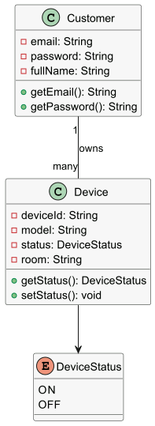

**2. Gateway Dashboard Diagram**

Gateway dashboard diagram Illustrates the interaction between the User, Dashboard, Gateway, and Device components during device control operations. Simulates the socket communication flow for sending commands and receiving acknowledgments.

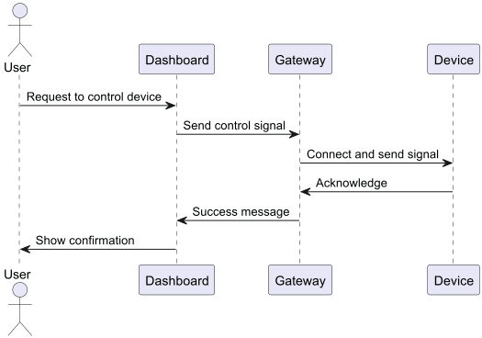

**3. Use case Diagram**

Use case diagram provides a high-level, visual overview of a system’s functionality. It shows how users and devices interact with each other to achieve a specific goal.

Key components are:

Actor: Customer

Use cases: Register, Login, View Devices, Control Devices, Change device Status and Exit

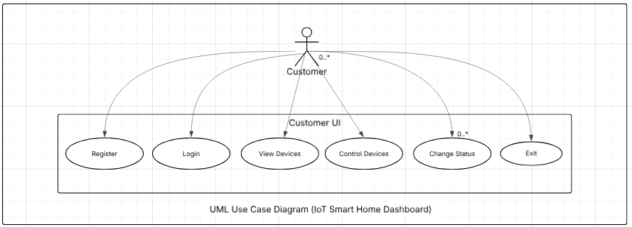

**4. Conclusion**

On **Day 2**, the IoT Smart Home Dashboard design was documented using **UML Class Diagrams** for Customer, Devices, along with an **Gateway diagram** and **Use case diagram.**